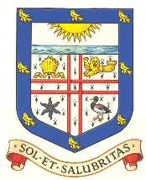

Bexhill Trust

Annual Report 2024

Constitution

The Bexhill Trust is managed by a body of Trustees comprising up to seven “Ordinary Trustees” appointed by Bexhill Town Council together with the Town Mayor and Deputy Town Mayor as “Ex-Officio Trustees” for their respective terms of office.

Trustees

Chairman – Brian Drayson

Trustees – Sarah Errington, Viv Taylor-Gee, Eleanor Gibson

Ex-Officio Trustees (non-voting)

The Bexhill on Sea Mayor and Deputy Mayor – no in person meetings held during 2024 so there has been no opportunity for them to attend. Links will be restored in 2025

Application of Income

The Trust’s funds are at the absolute discretion of the Trustees, applied for the public benefit to recipients within the former Borough of Bexhill* and specifically for:

The relief of poverty

The advancement of education

Any other charitable object of public utility

Meetings

Throughout 2024 four meetings were planned i.e. Jan 2024. May 2024, July 2024 and Nov 2024, however the loss of The Clerk early in 2024 and who has not been replaced meant none of the Scheduled meetings took place.

Grant applications were considered throughout the year where information was circulated electronically.

In-person Meetings will be scheduled and held in 2025 although applications may continue to be considered ‘electronically’ where this is felt to be expedient.

*now within the area administered by Bexhill on Sea Town Council

Grants Awarded

Within the year a total of 3 grants were awarded, totalling £2744.

Finance

£

Income (Instant Access Account interest only) 164.24

Expenditure Grants 2744.00

Unity Service Charge 71.40

Other 100.00

Total: 2915.40

Deficit: 2751.16

Assets

Blackrock Investments (Value decrease on 2023) 75454.51

NatWest (Suspended account) 40000.00**

Unity Savings Account 6067.69

Unity Current Account 3668.71

Total: 125190.91*

** I am unable to confirm the exact figure held in the Nat West Bank suspended account due to GDPR. I have been able to confirm it is in the region of the figure shown. Action will be taken to reactivate this account and use the money for charitable purposes.

During 2024 a NatWest Account containing £83.76 was closed and the money transferred to the Unity Current Account.

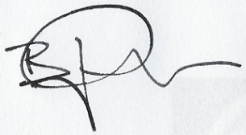

Brian Drayson

Chair

